### **Hazardous Area Monitoring For Industrial Plant Powered By IoT**

### **Building Mobile App**

# **CONFIGURE THE MOBILE APP FOR CONTROLLING MOTOR USING BUTTONS**

**TEAM ID** : PNT2022TMID41953

CONTROL DC MOTOR:

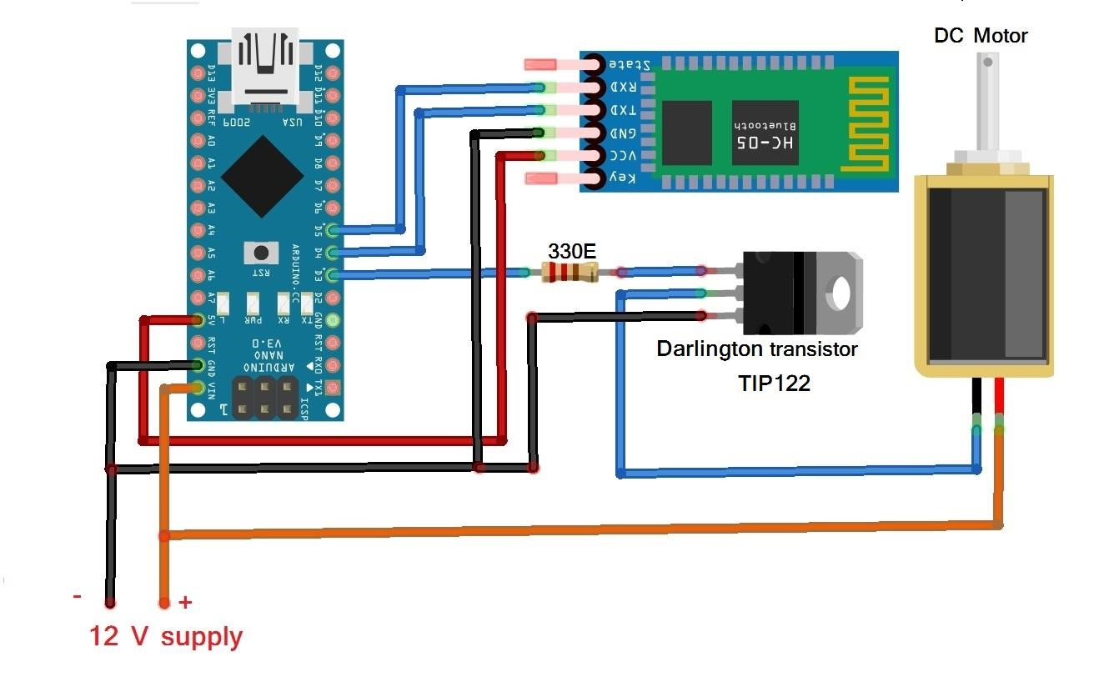

CONTROL SERVO MOTOR:

